Tests DHCP

**Sur le client :**

*Ip addr DNS maitre*

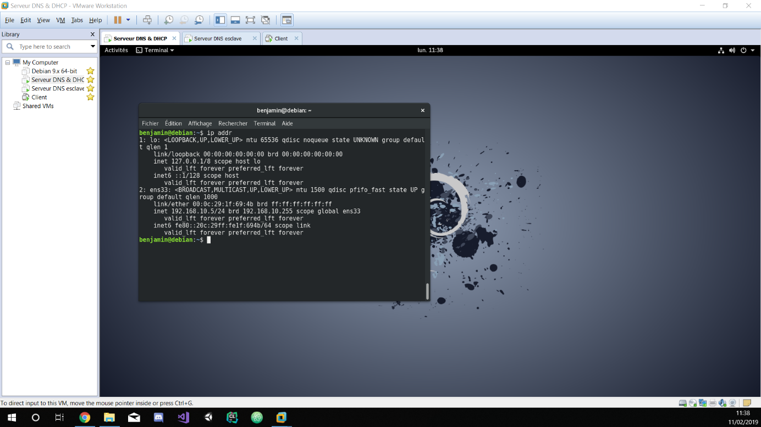

*ip addr DNS esclave*

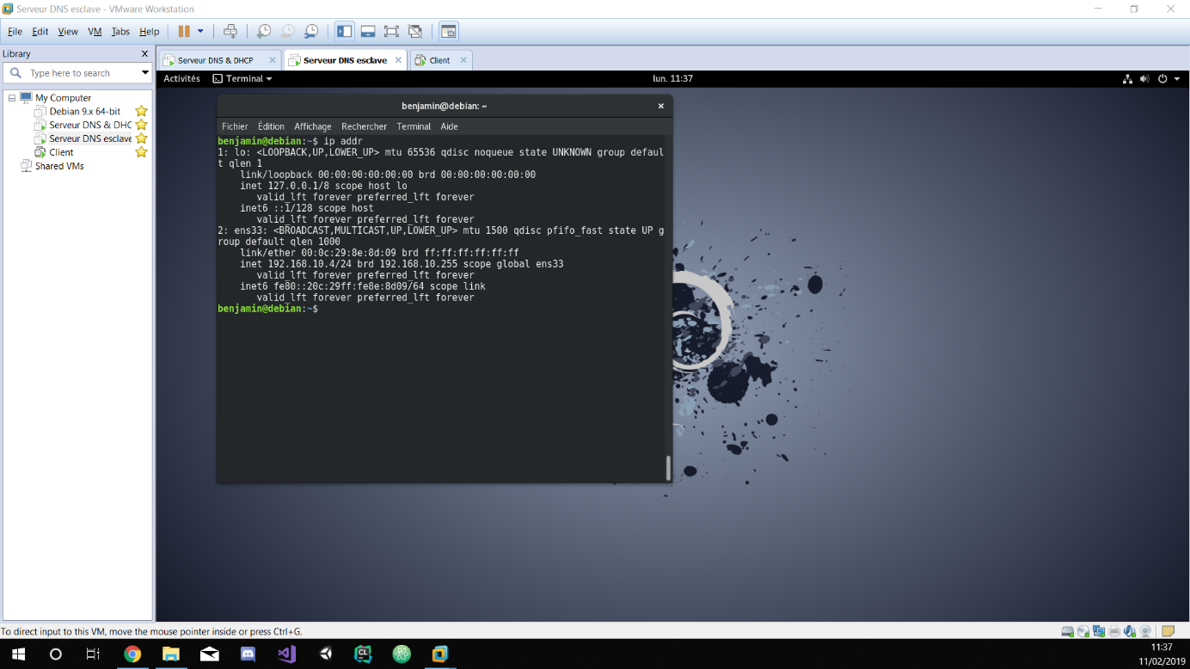

*ip addr client*

